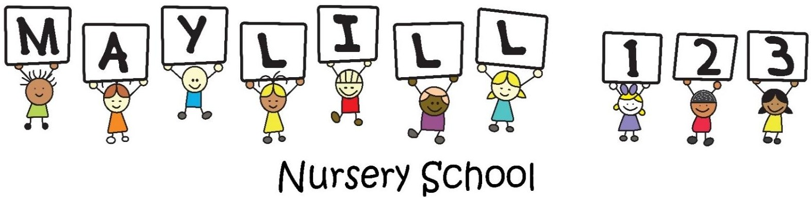

ENROLMENT FORM 2027
LEARNER
Surname
Name
Date of Birth
Gender
Race
Religion
Home Language
Medical Aid Name and Number
Medical Conditions – Medication
Allergies – Food/other
MOTHER
Surname
Name
ID Number
Residential Address
Employer
Occupation
Employer Address
Work Telephone
Cellphone Number
E-mail Address
Marital Status

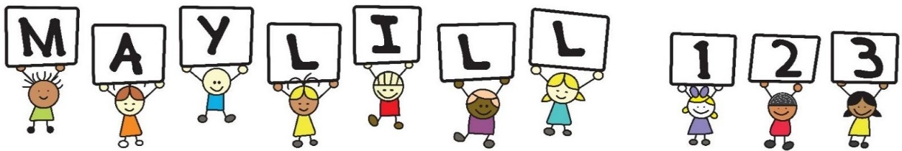

FATHER
Surname
Name
ID Number
Residential Address
Employer
Occupation
Employer Address
Work Telephone
Cellphone Number
E-mail Address
Marital Status
ADDITIONAL CONTACT
Name and Surname
Cellphone Number
Additional Number
Relation to the Child
FEES
Enrolment Fee (Once off) |  | R1 000
Full Day (06:30-18:00) |  | R4 260
FEES PAID BY
Name
Surname
ID Number
E-mail Address
Relation to the child
Fees are due every month by the 1st, for a period of 12 months. Service will be suspended if nonpayment occurs. Bad debt will be handed over to Scorpion Tracing and Collections and you will be held liable for all legal fees incurred. No subtraction/reduction of fees will be taken into consideration because of absence, illness, or holidays. A pro rata fee will be charged where applicable. One month’s paid written notice must be given by the 1st of the month if you wish to remove your child/ren from school. Notice will not be accepted for the months of November and December.
DOCUMENTATION TO BE SUBMITTED
- IDs of both Parents
- Clinic Card (All Pages)
- Birth Certificate
- Most recent report card

CONSENT & INDEMNITY
We, the undersigned agree to the terms and conditions as set out below by Maylill 1-2-3 Nursery School (Pty) Ltd:

Staff to act in loco parentis as they deem fit under all circumstances. In case of an emergency, your child will be taken to the nearest doctor/hospital for observation. Maylill 1-2-3 Nursery School will not be held liable for any fees incurred. While the utmost care will be taken at all times, we will not be held responsible for any injury, accident or illness. All allergies, illness and important medical information must be disclosed. Contagious diseases eg. Measles must be notified to the school immediately and a doctor’s note authorising the child to return to school is required. Contact details must be updated at all times by e mail.

POPI ACT
Maylill 1-2-3 Nursery School complies with the Protection of Personal Information Act (POPI), therefore by entering this contract and unless you at any time instruct the school to expressly and in writing to the contrary, your consent is given for the school to:

- Collect, store and process credit information about you and any third party or divorced or separated parent responsible for payment of any or all amounts compromised in the fees.
- Acknowledge that your information will be shared with Scorpion Tracing and Collection in the event of debt recovery.
- Collect, store and process names contact details and information relating to yourself and your child, and to such information being made available to other parents/guardians, staff or responsible persons engaged or authorized by the school for school-related purposes to the extent required for the purpose of managing relationships between the school, parents/guardians, and current learners as well as providing references and communicating with the body of former learners.
- Supply information and a reference in respect of your child to any educational institution which you propose your child may attend. We will take care to ensure that all information that is supplied relating to your child is accurate and any opinion given on his/her ability, aptitude and character is fair. However, the school cannot be held liable for any loss you or your child is alleged to have suffered resulting from opinions reasonably given, correct statements of facts contained, in any reference or report given by us; and
- Inform any other school or educational institution to which you propose to send your child of any outstanding fees. The school may not distribute or otherwise publish any of your personal information in its possession, unless you give your consent, in writing, to the school that it may do so.

I, …………………………………………the parent/guardian of ………………………………………………agree to the terms and conditions as set out above.

Signed on this ………………………… day of ……………………………. 20….

 | Name | Signature | Date
Mother
Father
Guardian
Principal

